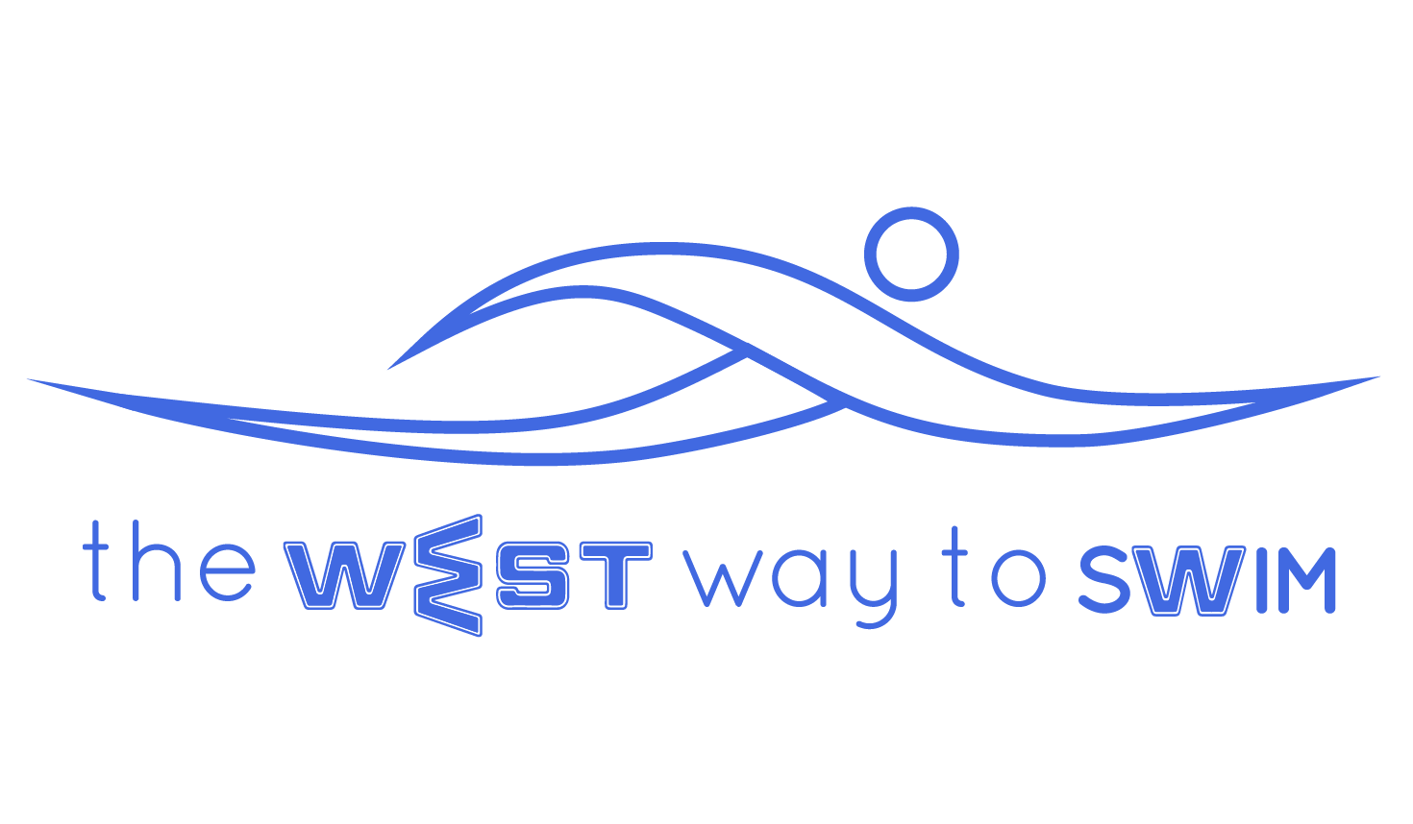
4.0 The goal of session #4: Lengthening of strokes, mastering swimming 12 strokes per length with fins and understanding your personal number of strokes per length when swimming freestyle with and without fins.
No | The Drill & Goals | Duration in min | WEST Key Principles | From theory to practice
4.1 | 6-14 X25 with fins, no breathing.  Fin stretch at end of every length | 10 | 2.5.1 - Fin stretch | Swim a length of freestyle (25m) with fins, without breathing. Just before you run out of air rotate for a breath. Try not to swim faster when you feel you’re running out of air. Try to keep to 12-14 strokes per length. You are allowed some legwork only at the end of the stretch to generate a low stroke count.  Swim 6-14 lengths, as many as you get inside 10 minutes.  After each length do 10 sec of fin stretch (2.5.1) for each leg, for a total of 20 sec rest.
4.2 | 100-300 meters in breathing position with fins | 6 | 3.4 - Breathing position | Swim in breathing position (3.4 - one eye in the water, mouth and nose out of the water) with fins, 25m with right arm leading, and 25m left arm leading.
4.3 | 6-14X25 freestyle with fins,with breathing. No more than 12 strokes per length. | 8 |  | Swim freestyle with fins, breathing every 3 strokes, making exactly 12 strokes per length (10 strokes for 10 Yards). If you see you get to 10 strokes, kick less with your legs, and if you see you’re going to have more than 12 strokes, add some legwork at the end of the stretch. 15 sec rest between lengths.  Swim 6-14 lengths, as many as you get inside 8 minutes.
4.4 | 2-4X100 freestyle without fins, with breathing, rotating to supine position with every breath (exercise 2.7) | 10 |  | Swim 2-4 times 100m freestyle, breathing every 3 strokes through rolling on your back while maintaining “Superman” position (one arm stretched forward and the other alongside body)  After every 100m’ rest for 30 sec, performing stretches of your choice.  If the drill is too hard, you can perform some of it using fins.
4.5  4.5.1 | 6-14X25 with no fins, minimum number of strokes, breathing every 3.  Between every 25, inverted streamline stretch.  Inverted streamline stretch. | 10 | KP1- Shape of palm  KP5- Depth of stretch  KP8- Head position in water  All according to personal WEST  4.5.1 - inverted streamline stretch. | Swim 6-14 times 25m freestyle, and on each length concentrate on a different KP: Shape of palm, Depth of stretch and head position in the water, all according to your personal WEST.  Try not to do any legwork, and keep your strokes to a minimum.  Between lengths rest for 20 sec in which you do inverted streamline stretch.  4.5.1 - inverted streamline stretch.  At the end of the drill do inverted streamline stretch again.
4.6 | 2-5X100 freestyle with fins, between each 100 meters, 30-45 second break & stretch. | 8 |  | Swim 2-5 times 100m freestyle with fins, breathing every 3, maintaining 12 strokes per length (14 max).  Between each 100m rest 30-45 sec, performing stretches of your choice.
4.7.1  4.7.2 | Remove fins: 100 meters freestyle breathing every 3 strokes. At the end of the 100 meters,  Arm and leg stretches | 8 | 4.7.2 - Arm stretch behind back  3.7.3.1 - Ankle stretch  4.7.3 - Elbow behind head | Try and swim 100 meters continuously, breathing every 3 strokes. If rest is needed between lengths, rest a few seconds and continue. On the 4th length, count your strokes.  At the end, perform stretches for the remainder of the time:  4.7.2.1 - Arm stretch behind back - One hands holds the other behind your back and lift upward slowly until you reach maximum extension while maintaining a straight back.  3.7.3.1 - Ankle stretch- place heel on the floor, toes extended on the wall and lean body forward towards the wall. After 10 seconds - change legs.  4.7.3 - Elbow behind head - Hold one elbow with opposite hand and bring elbow behind head. Once you’ve reached maximum extension you can rotate body to the same side to increase extension to the side of the body.
4.8- Write down the distance you have swum in each session and take note if there has been a change.

4.9 - Weekly tip: shape of palm, depth of stretch, long glide and neutral head will assist you with reducing your stroke rate. A low stroke rate is created by extension of the glide and not by a stronger pull under the water..

